# CS 255 System Design Document

## UML Diagrams

### UML Use Case Diagram

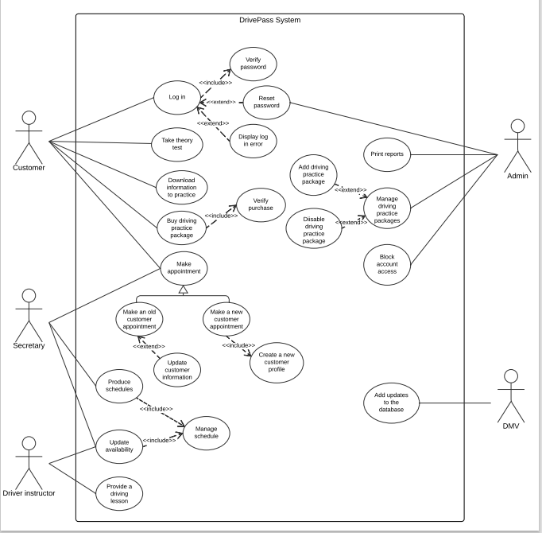

### UML Activity Diagrams

‘Login’ use case

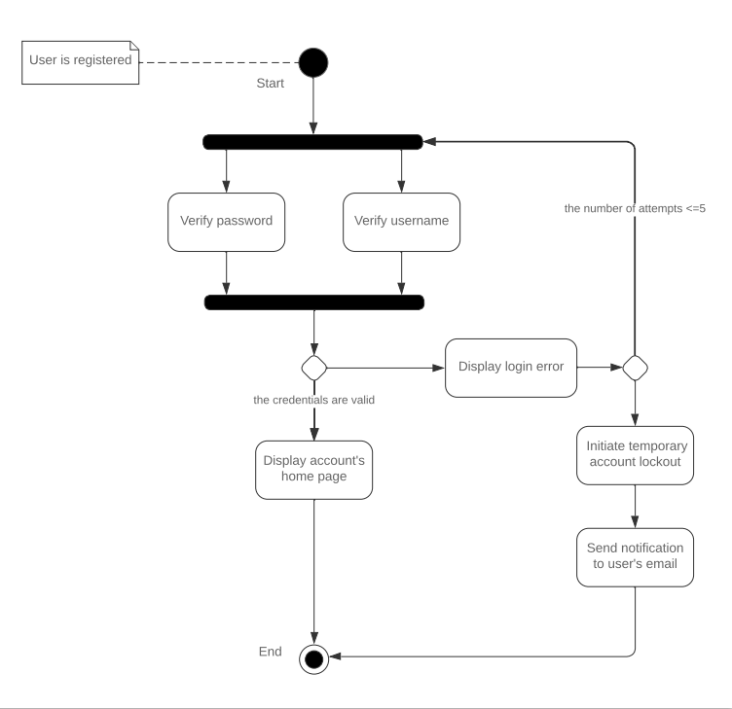

‘Taking a theory test’ use case

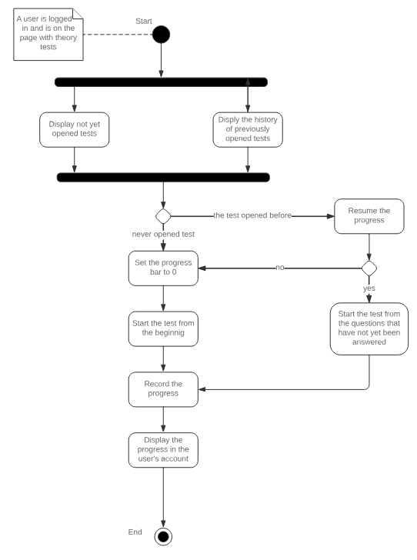

### UML Sequence Diagram

Driving package purchase

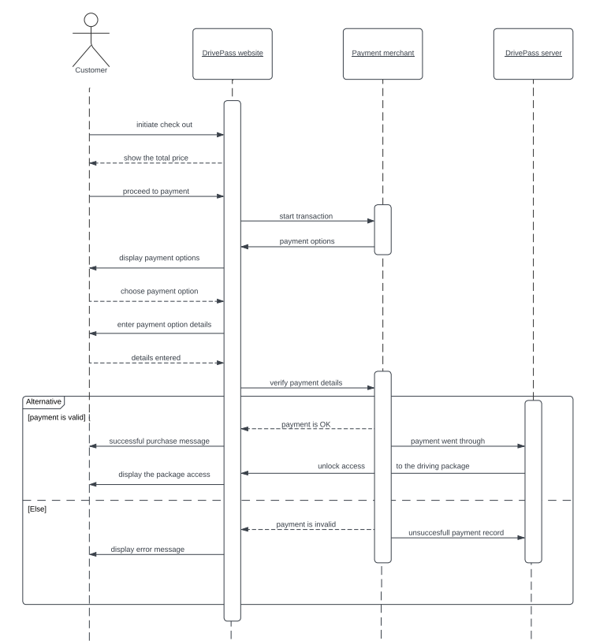

### UML Class Diagram

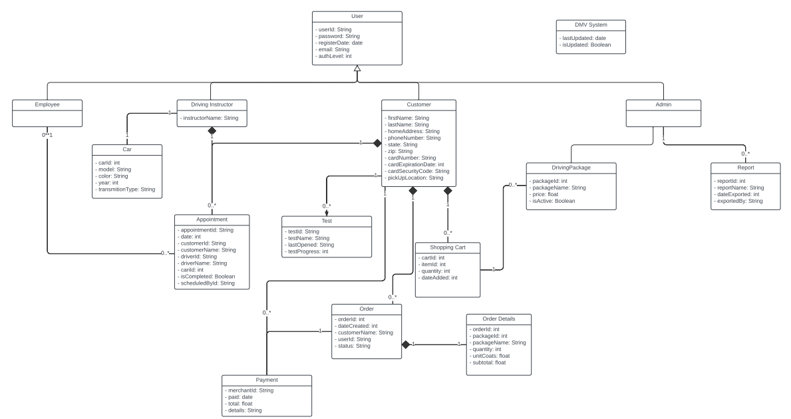

## Technical Requirements

*Based on the created diagrams, some of the technical requirements for the DrivePass system are:*

* stable internet connection
* caching to access studying material offline
* computer/mobile device to access the website
* operating system and browser to access the website
* database management system, SQL (recommended)
* cloud server
* cloud storage
* firewall
* authentication system to differentiate user access
* DMV system integration for continuous updates
* encrypted data exchange
* payment merchant API integration
* backup software